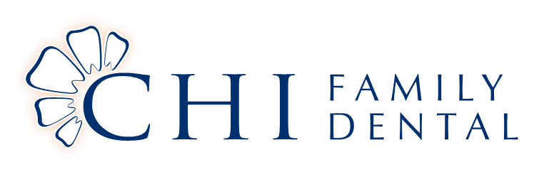

***This notice describes how medical/ Dental information about you may be used and disclosed and how you can get access to this information. Please read it carefully.***

We understand that the privacy of your personal information is important to you. As your dental office, we believe your right to privacy is a fundamental part of your treatment; as such, we want you to understand our privacy practices and procedures. Should you have any questions regarding these policies please do not hesitate to call the office at 281-778-9261

*Information We Collect About You*

We collect personal information about you and your family as part of our new patient process, during the course of your care, and from other health care entities you utilize such as, other dentists and specialists, imaging facilities, laboratories and your insurance company. This personal information includes items such as your name, address, phone number, birth date, social security number, employer, health history, insurance policy and coverage information and any information you provide. During the course of your treatment we will collect Dental information regarding diagnosis, treatment plans, progress and any test results or films.

*How Your Information Is Used*

The personal and health information gathered may be used and disclosed with your general consent for purposes of treatment, payment, or routine healthcare operations. This means we may send your information to other dentists or facilities involved in your treatment as well as to your insurance company or a collection agency to obtain payment. Any other uses of your information require a signed authorization by you, the patient or guardian and can be revoked in at any time with a written request. Chi Family Dental does not sell patient information to marketing or pharmaceutical companies. In certain cases of public health interest we may be required to disclose certain information to local, state or national health organizations or government agencies.

We may contact you to provide appointment reminders or information about treatment. *Safeguarding Your Personal and Health Information*

We are required by law to (1) make sure that medical information that identifies you is kept private (2) provide you with our privacy policy (3) follow the terms laid out in the privacy policy. As a means of protecting your privacy, we restrict access to your personal and health information to only those employees who require the information to complete their jobs and provide quality service to you.

Chi Family Dental maintains physical, electronic and procedural safeguards to comply with state and federal regulations that guard your personal and health information. If you feel your privacy has been violated you have the right to file a complaint with the Department of Health and Human Services. The complaint in no way influences your course of treatment with Chi Family Dental

*Changes to Our Privacy Policy*

All new patients will review a copy of our privacy policy. Chi Family Dental occasionally reviews its privacy policy and reserves the right to amend it. Notification of changes will be available at the front desk prior to the effective date of any changes.

*Your Right to Restrict Use of Information*

You have the right to request restrictions to our uses or disclosures of your personal or health information, although we are not required to agree to those restrictions. Once your request has been processed it will remain in effect until you request a change.

Patient Acknowledgement

I have reviewed Chi Family Dental’s Privacy Policy

Signed Date